**snowflake**

step by step:-

🡪open google crome

🡪click on start for free

🡪fill to popup

🡪open the snowflake enrollment

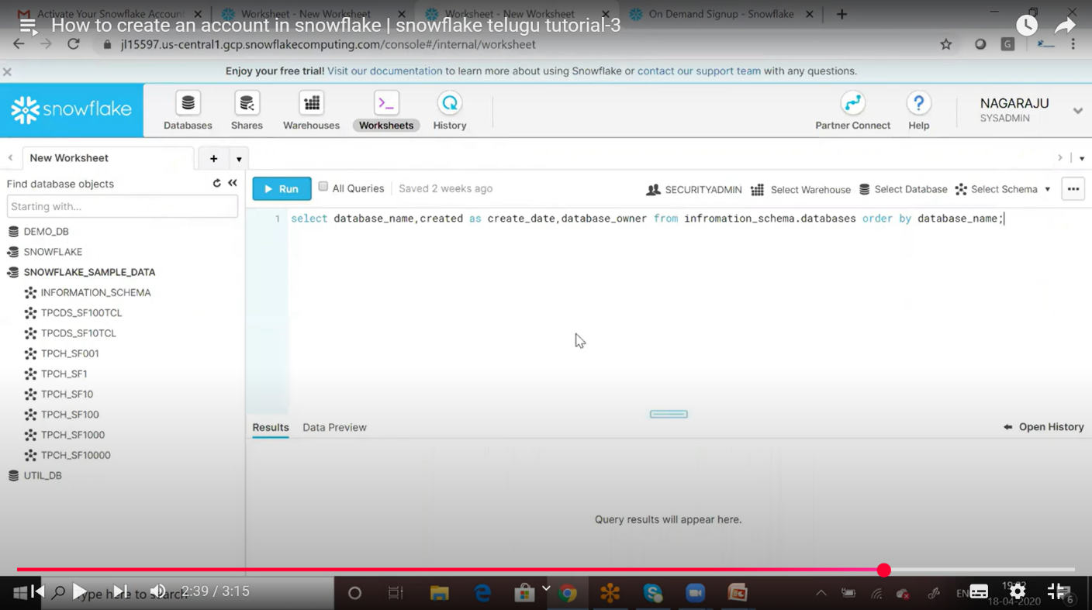

**Create databases & tables in snowflake:-**

**Steps:-**

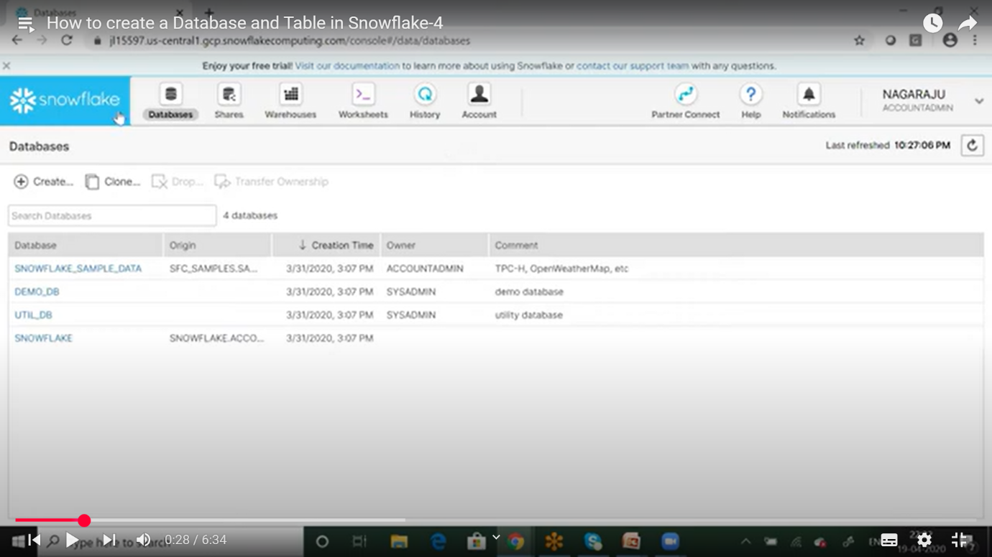

🡪Click on (+) or create

🡪create database box

🡪name:- new database name Ex:-(LOKALDB)

🡪comment:-my lokaldb

🡪click on show SQL

🡪show SQL box:-

🡪Query:-create database LOKALDB comment=”my lokaldb”;

🡪 click on close box

🡪 click on finsh box

Create a new databases:-

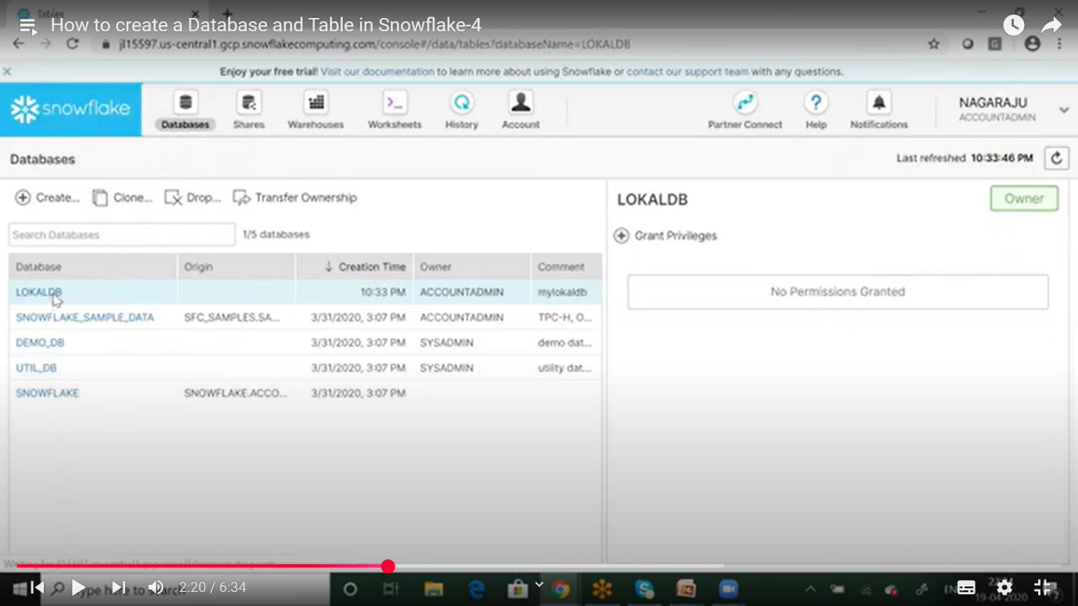

🡪Click on LOKALDB

**Create new tables:-**

🡪 Click on (+) or create a table

🡪 create table box

🡪table name:-EMPDATA

🡪schema name:-PUBLIC

🡪COMMENT:-my emy data

🡪columns:-click on (+)Add

🡪name type not null default

EMPNO INTERGER

EMPNAME STRING

SAL INTERGER

🡪click on finsh

Create a new table:-

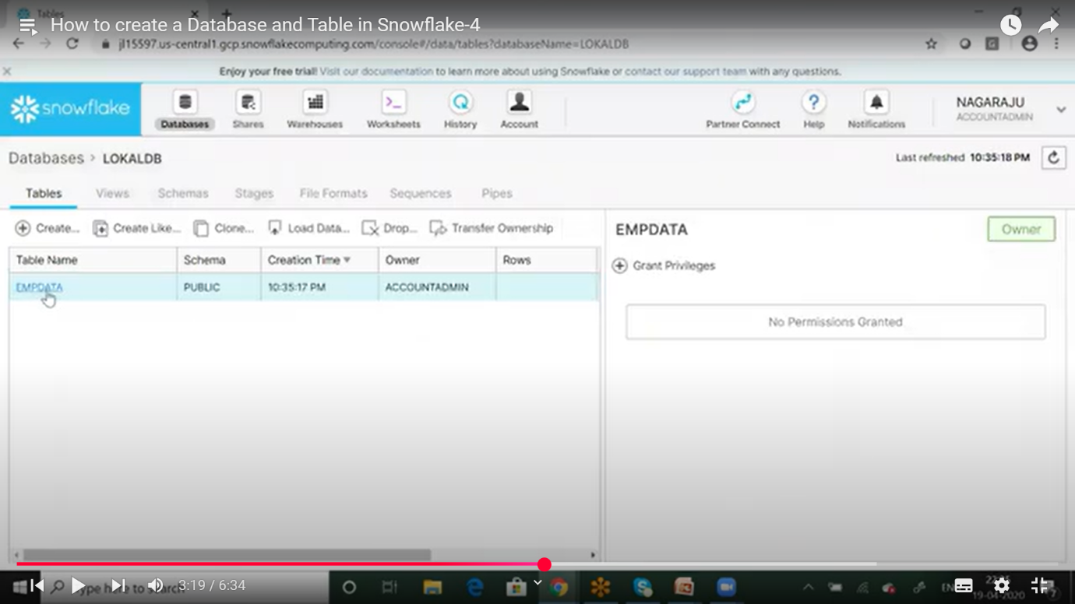

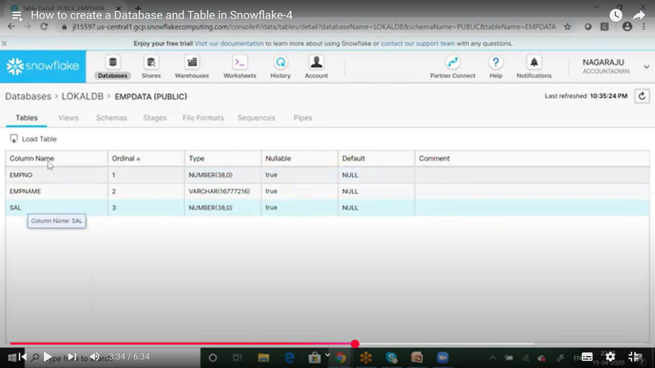

🡪click on load table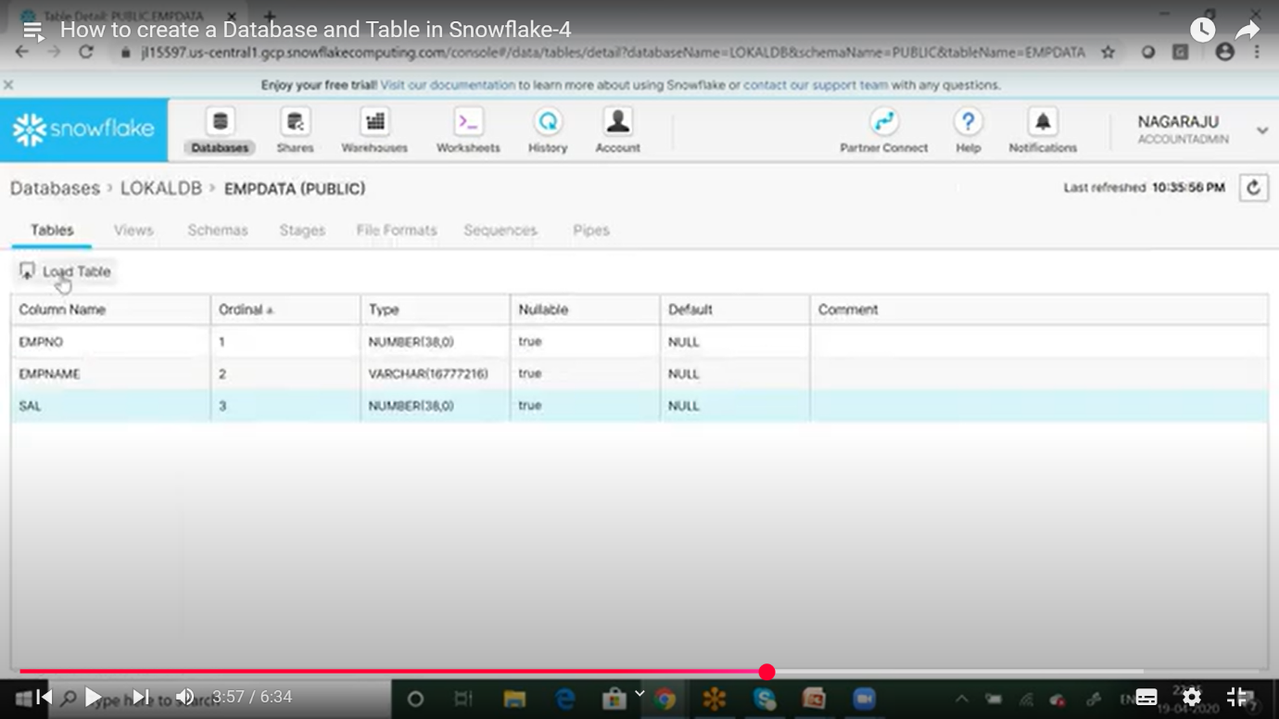

🡪open the popup box

🡪select the warehouse

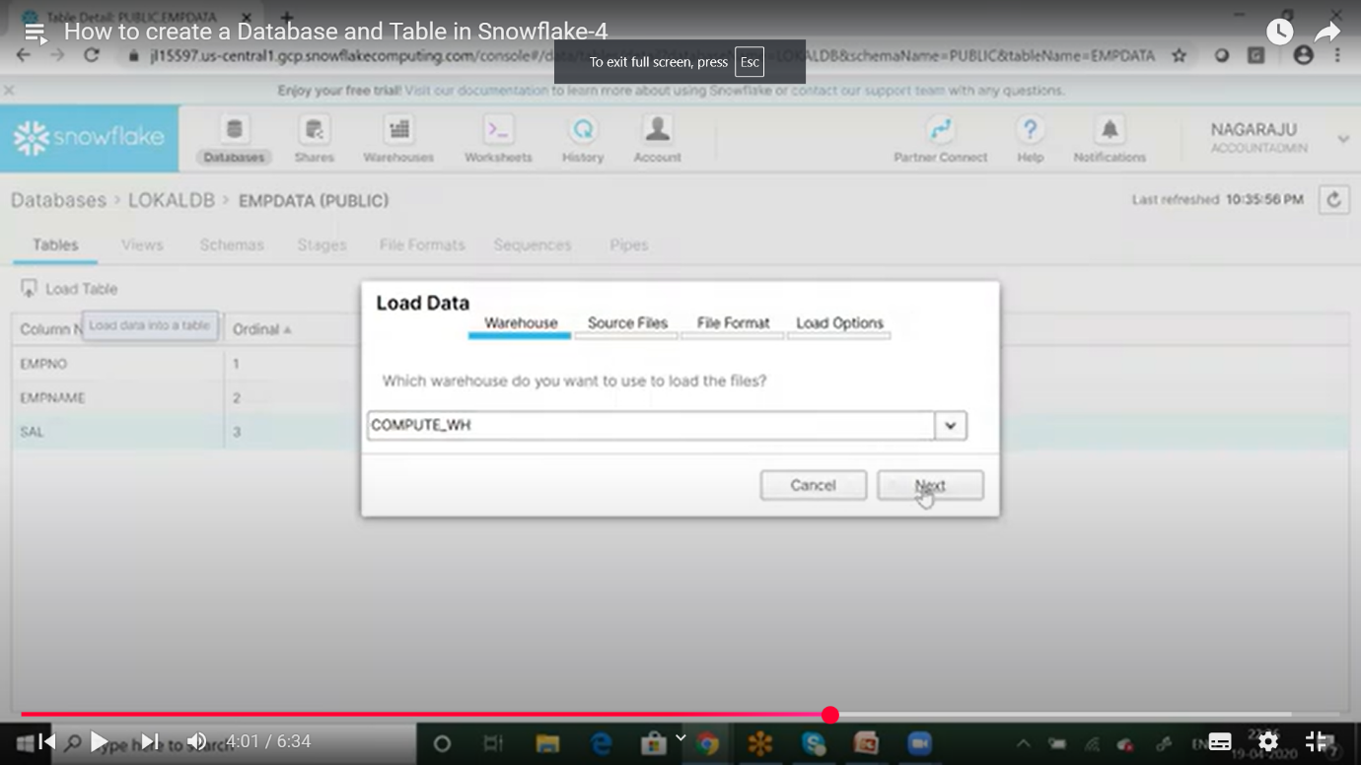

🡪click on the next

🡪open the popup box

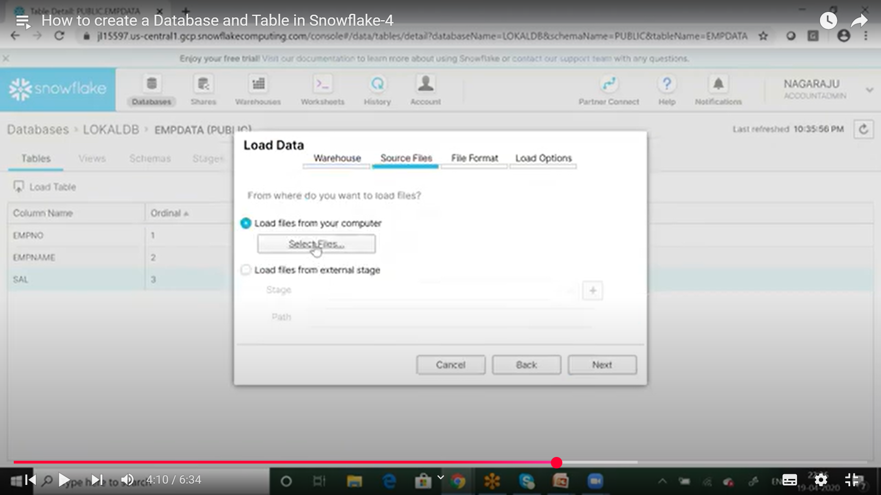

🡪type path name

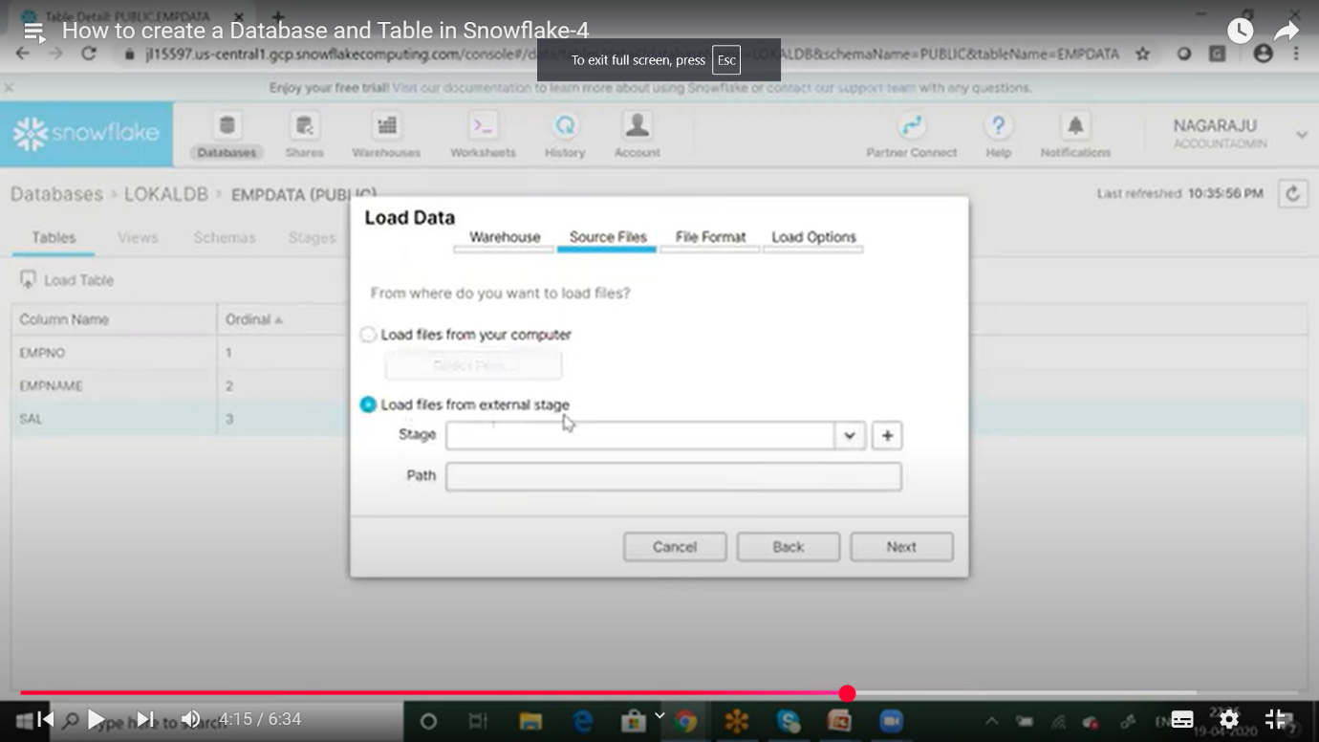

🡪click on select CSV file

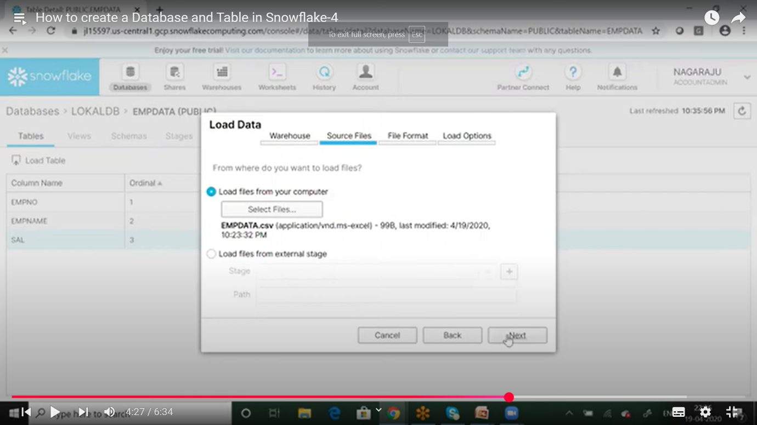

🡪click on the next box

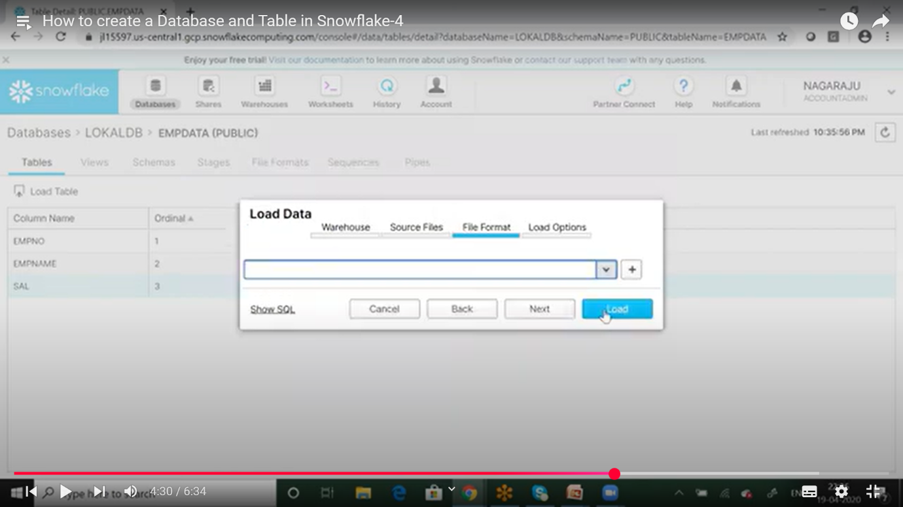

🡪Click on the load option

🡪load a CSV file

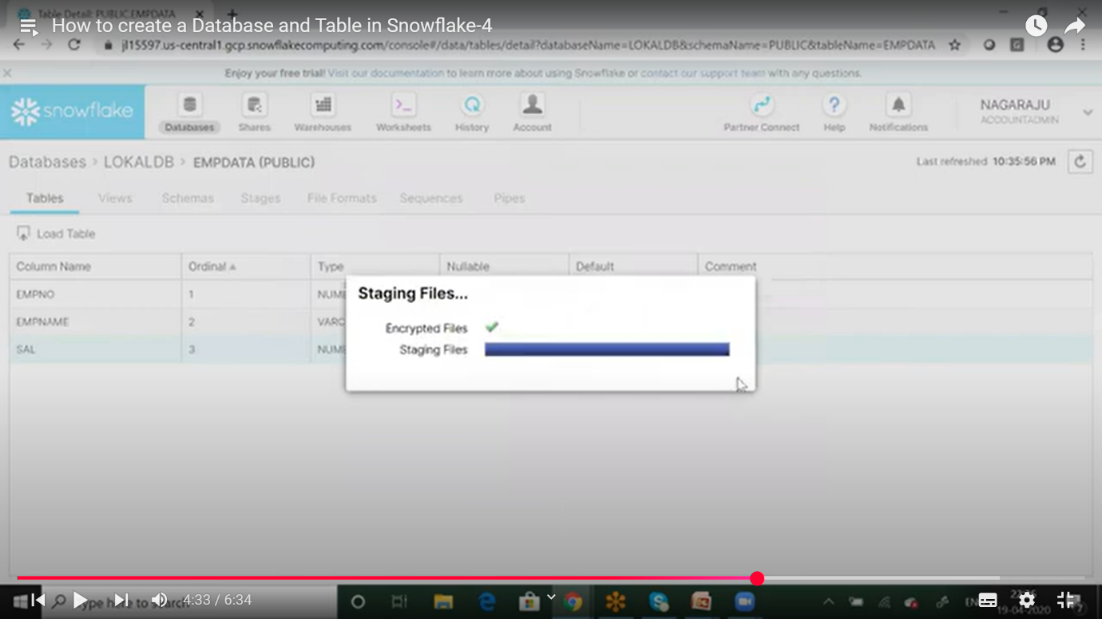

🡪show load results popup box

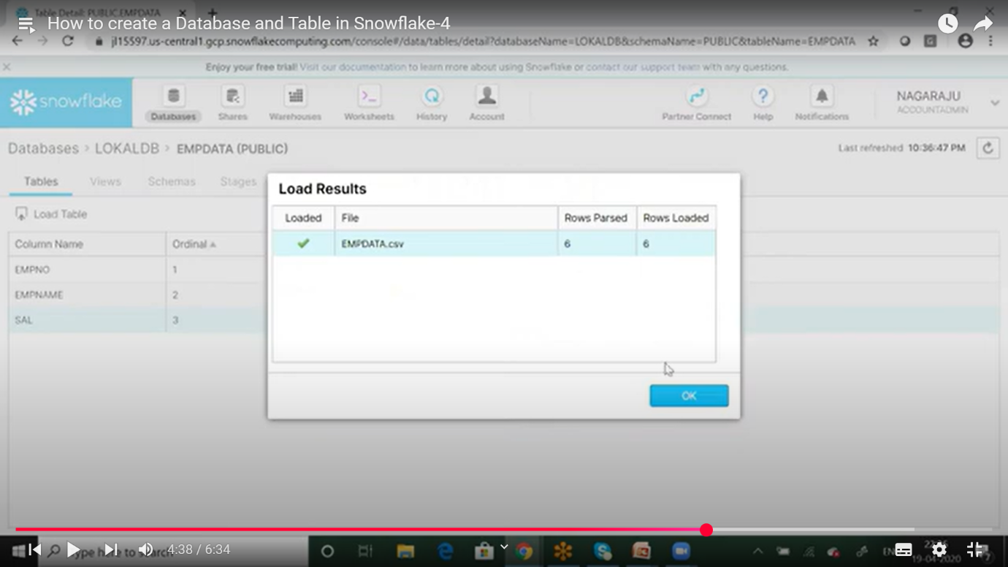

**Create worksheets:-**

🡪click on the worksheet

🡪click on the my database

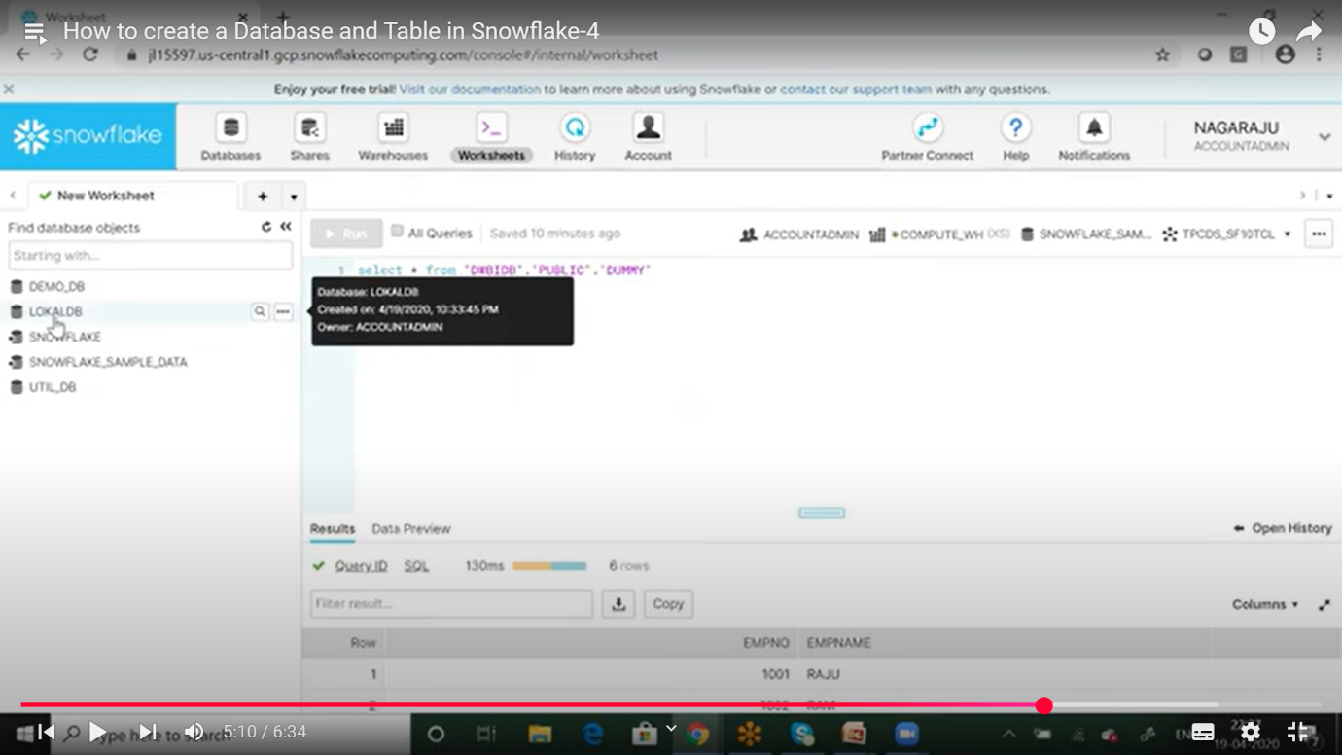

🡪click on the my schema

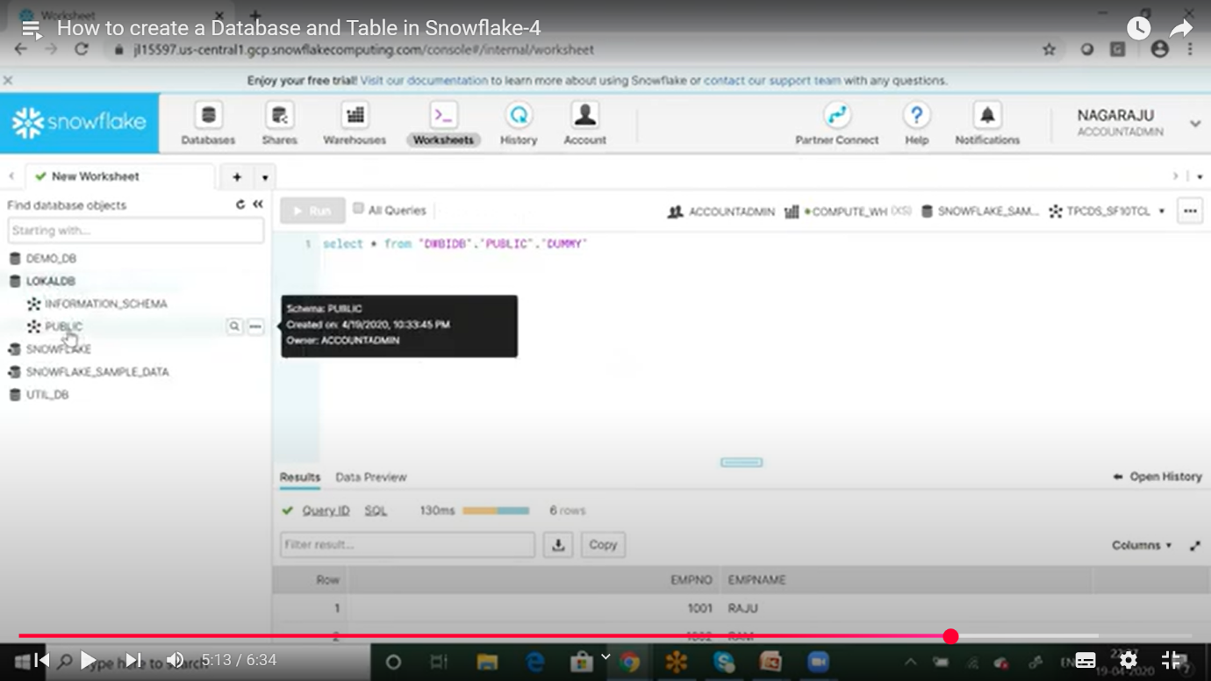

🡪click on the my table

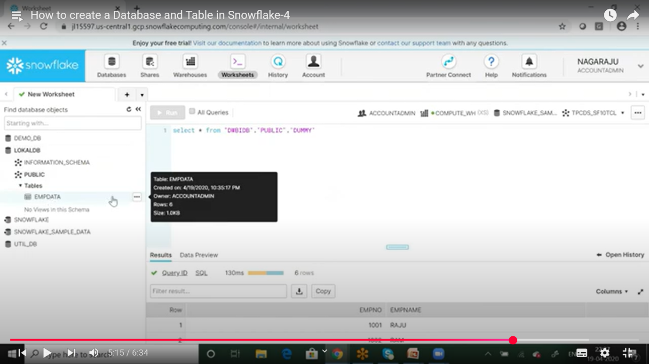

🡪Query process & Generate outputs (or) load chesina na CSV files output

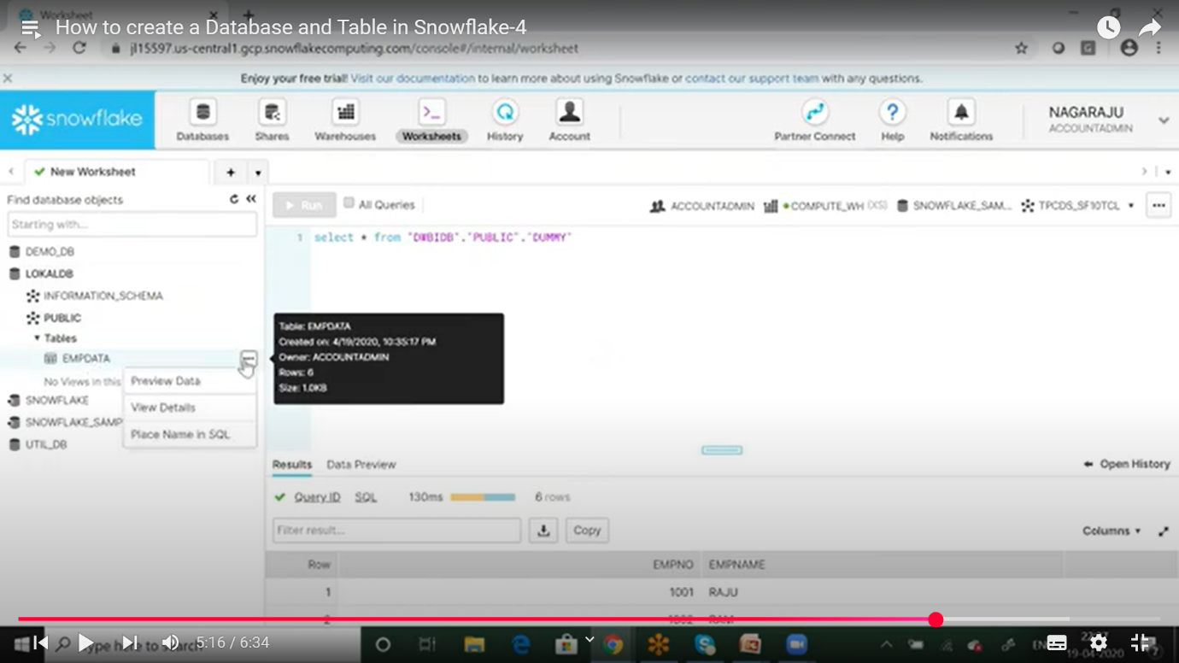

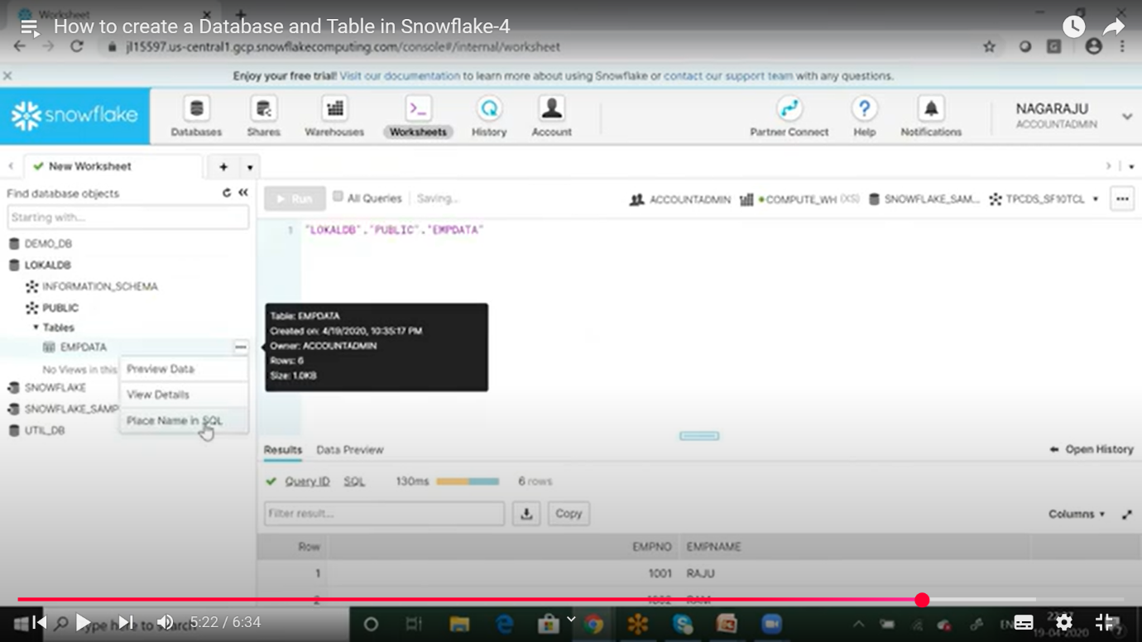

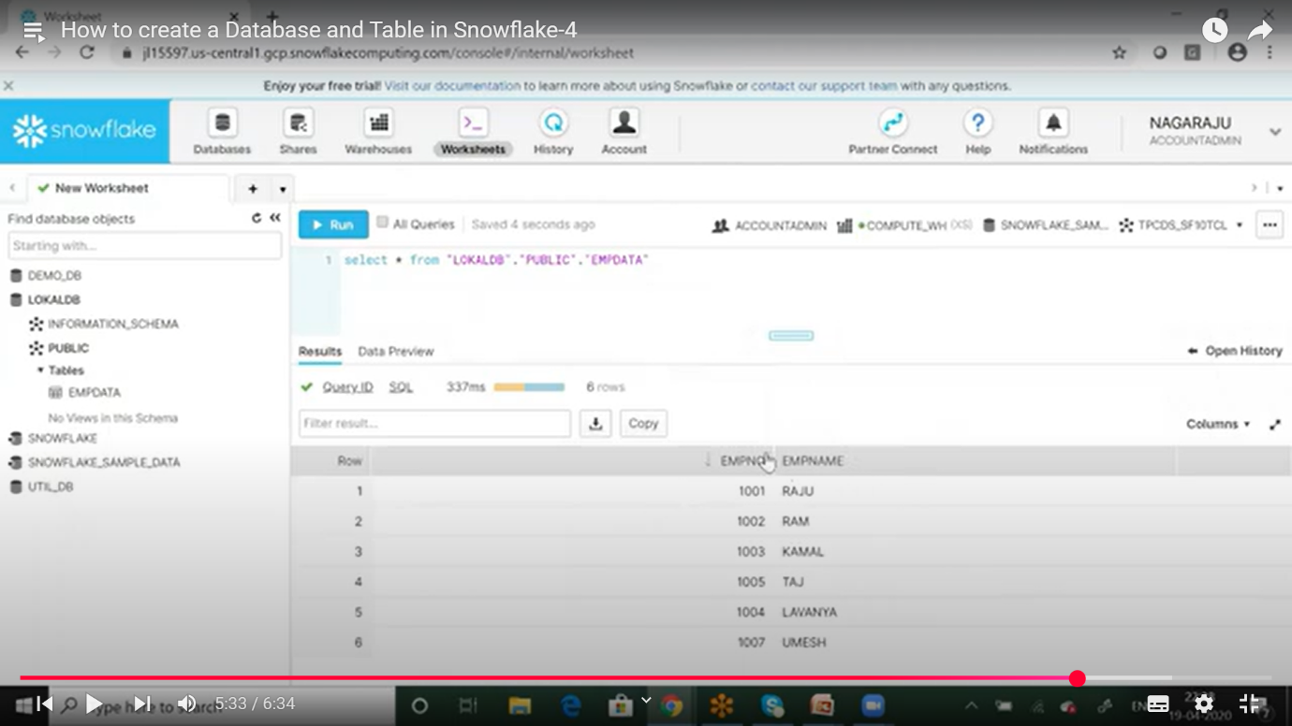

* Ee vidhaga snowflake lo oka new datawarehouse create chesi, andhu lo oka new table ni create chesi ,ee create chesena table ne CSV file ga load chesi,worksheets ne open chesi endhulo oka new worksheet ni open chesi endhulo oka SQL Qurey rasi dhini run chesthe ,manam load chesina CSVfile yyokka outputs anevi generate avvthayyee.